3/15/2024

Xiaolin Wu

Yingchun Gao

Chunhua Li

Food Waste Reduction Platform

Contents

**1.Version History** 1

**2. Introduction** 2

**3. Targeted Audience** 3

**4. Scope** 4

**5. Application Architecture** 5

5.1 Presentation Layer 5

5.2 Business Layer 5

5.3 Database Layer 5

**6. Business Architecture** 7

6.1 General Use Cases 7

6.2 Retailer Use Cases 8

6.3 Charitable Organization Use Cases 9

6.4 Consumer Use Cases 11

**7. Detailed Design** 13

7.1 Class diagrams 13

**8. Data Architecture** 14

8.1 Database Structures 14

**9. Security Architecture** 15

9.1 Strong Password Policies 15

9.2 Session Management 15

**10. Testing Model** 16

10.1 Testing Approach 16

10.2 Tools 16

**References** 17

**Acronyms/Abbreviation** 18

List of Figures

Figure 1 Application architecture diagram 6

Figure 2 Visitor use case diagram. 7

Figure 3 Food retail use case diagram 9

Figure 4 Charitable organization use case diagram 10

Figure 5 Consumer use case diagram 12

Figure 6 Class diagram 13

Figure 7 ERD of Food Waste Reduction System 14

List of tables

Table 1 Version History 1

# **Version History**

Table 1 Version History

|  |  |  |
| --- | --- | --- |
| Version # | Author | Date |
| 0.0 | Chunhua Li  Yingchun Gao  Xiaolin Wu | March 13,2024 |

# **2. Introduction**

The Food Waste Reduction Platform (FWRP) aims to address the global issue of food waste by providing a comprehensive solution that connects food retailers, consumers, and charitable organizations. This FWRP plays a vital role in promoting sustainability, reducing hunger, and building more resilient food ecosystems. It encourages collaborating among stakeholders across the food supply chain and encourages collective action to address one of the most important challenges of our time. The platform facilitates the efficient redistribution of surplus food.

The high-level design document outlines the architecture and functionalities of the FWRP.

# **3. Targeted Audience**

The Food Waste Reduction Platform (FWRP) is designed to benefit food suppliers, charitable organizations or non-profit organizations, and consumers. Food suppliers encompass a wide range of entities, including food manufacturers, distributors, and retailers.

# **4. Scope**

In Scope:

* User registration and authentication
* Inventory management for retailers.
* Surplus food identification and listing
* Claiming food by charitable organizations
* Purchasing by consumers
* Surplus food alerts
* Database design and management
* Application, business, data, security, and deployment architecture
* Testing Model

Out of Scope:

* Real financial transactions
* Real Automatic Notifications Email/Phone

# **5. Application Architecture**

The FWRP follows a three-tier architecture.

## 5.1 Presentation Layer

* User Interface (UI)
* Model-View-Controller (MVC) pattern for interaction with users

## 5.2 Business Layer

* Business logic and functionalities
* Processing of user requests

## 5.3 Database Layer

Relational Database Management System (RDBMS) for data storage and management

Figure 1 Application architecture diagram

# **6. Business Architecture**

## 6.1 General Use Cases

* A visitor browses list page showcasing surplus food on the Food Waste Reduction Platform (FWRP) and observes the competitive prices of available items. Intrigued, he seeks additional details. Upon clicking one item, the “Sign up” page is triggered, he is directed to a registration page.
* A registered user wants to access the updated list of surplus foods on the FWRP. He clicks on the “Login” button, input his username and password, and upon successful validation, are redirected to the list page.

Figure 2 Visitor use case diagram.

## 6.2 Retailer Use Cases

* A retailer aims to manage inventory, so he can monitor the expiration date of each product. Upon logging into the system, the retailer navigates to the inventory page. The retailer filters the list based on expiration dates. The Food Waste Reduction Platform (FWRP) arranges products based on their expiration date, with items nearing expiration appearing at the top of the list.
* The retailer wants to identify surplus food items. Upon managing inventory, the retailer utilizes a flagging system for products nearing their expiration date, typically within one week. The FWRP highlights these surplus foods for easy identification.
* The retailer wants to add the flagged products to a surplus food list. Upon identifying surplus items, the retailer has the option to add them to a dedicated surplus food list. The system therefore moves the flagged products to the surplus food list.
* The retailer wants to check the surplus food. Upon moving surplus food to the surplus food list, the list provides a view of all surplus items identified and managed by the retailer.

Figure 3 Food retail use case diagram

## 6.3 Charitable Organization Use Cases

* A charitable organization routinely seeks surplus food to support its initiatives. The charitable organization clicks on the “Login” button, input their username and password, and upon successful validation, are redirected to the list page. When the charitable organization identifies surplus food items and proceeds to the claim page by selecting the desired items. The charitable organization inputs the quantities of food items they wish to claim, the system dynamically updates to reflect the changes, ensuring accurate tracking of available surplus items and claimed quantities.
* A charitable organization wants to stay informed about surplus food availability through regular alert messages from the FWRP. They log into the system, click on the “subscribe” button, input their relevant information. The system is configured to send alert messages to the organization on a weekly basis, ensuring they stay updated about surplus food offerings and can plan their initiatives.
* A screen shot of a computer

  Description automatically generated

Figure 4 Charitable organization use case diagram

## 6.4 Consumer Use Cases

* A consumer wants to order surplus food items through FWRP. The consumer clicks on the “Login” button, inputs his username and password, and upon successful validation, is redirected to the list page. When the consumer browsers through available surplus food items and proceeds to the purchase page by selecting desired items. The consumer specifies the quantities, the system dynamically updates to reflect the changes, ensuring accurate tracking of available surplus items and purchased quantities.
* A consumer wants to stay informed about surplus food availability through regular alert messages from FWRP. He logs into the system, clicks on the “subscribe” button, provides his relevant information. The system is configured to send alert messages to the consumer on a weekly basis, ensuring he stay updated about the latest surplus food offerings.
* A screen shot of a diagram

  Description automatically generated

Figure 5 Consumer use case diagram

# **7. Detailed Design**

## 7.1 Class diagrams

Figure 6 Class diagram

# **8. Data Architecture**

## 8.1 Database Structures

Tables/entities include Users, Charitable Organizations, Food Inventory, Claims, Purchases, Subscriptions, etc.

8.2 Entity-Relationship Diagram (ERD)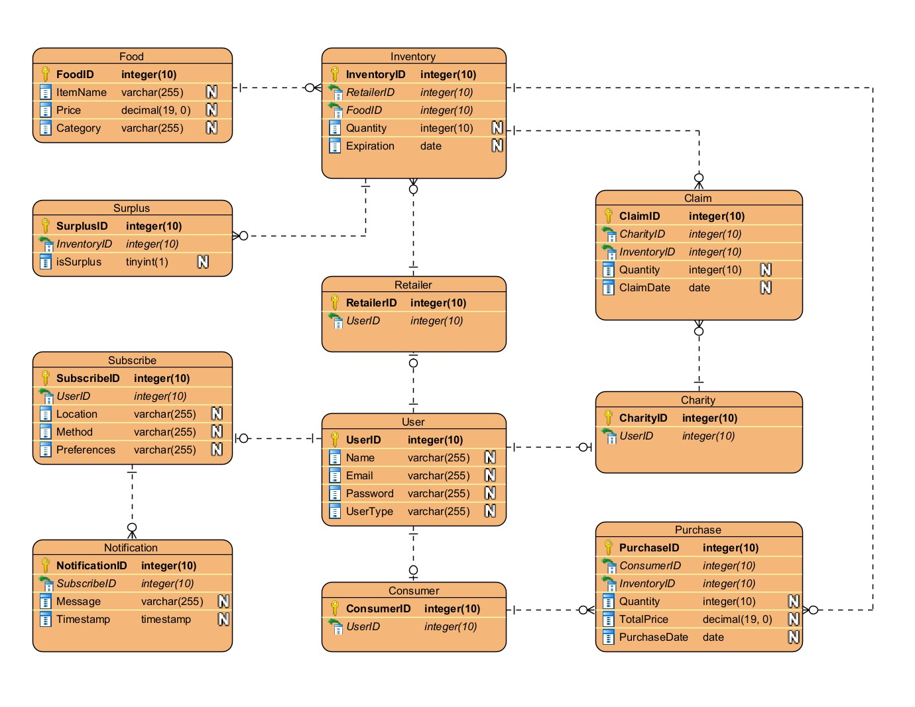

Figure 7 ERD of Food Waste Reduction System

# **9. Security Architecture**

## 9.1 Strong Password Policies

* Users will be required to create passwords that meet certain complexity criteria, such as minimum length, inclusion of alphanumeric characters, and special characters.

## 9.2 Session Management

* Sessions will be managed securely to prevent session hijacking and session fixation attacks.

# **10. Testing Model**

## 10.1 Testing Approach

* Unit testing using JUnit for individual components
* Integration testing for interaction between components

## 10.2 Tools

* JUnit

# **References**

1. What Is Session Management: Threats and Best Practices. (2023, 07 14). Retrieved from Authgear: https://www.authgear.com/post/session-management

# **Acronyms/Abbreviation**

* FWRP: Food Waste Reduction Platform
* RDBMS: Relational Database Management System
* UI: User Interface
* MVC: Model-View-Controller
* ERD: Entity-Relationship Diagram